## **Node.js**

Node.js is a single-threaded, open-source, cross-platform runtime environment for building fast and scalable server-side and networking applications. It runs on the V8 JavaScript runtime engine, and it uses event-driven, non-blocking I/O architecture, which makes it efficient and suitable for real-time applications.

## **What is the Event Loop?**

The event loop is what allows Node.js to perform non-blocking I/O operations — despite the fact that JavaScript is single-threaded — by offloading operations to the system kernel whenever possible.

Since most modern kernels are multi-threaded, they can handle multiple operations executing in the background. When one of these operations completes, the kernel tells Node.js so that the appropriate callback may be added to the **poll** queue to eventually be executed. We'll explain this in further detail later in this topic.

## **Node.js Architecture and How It Works**

## Node.js uses the “Single Threaded Event Loop” architecture to handle multiple clients at the same time. To understand how this is different from other runtimes, we need to understand how multi-threaded concurrent clients are handled in languages like Java.

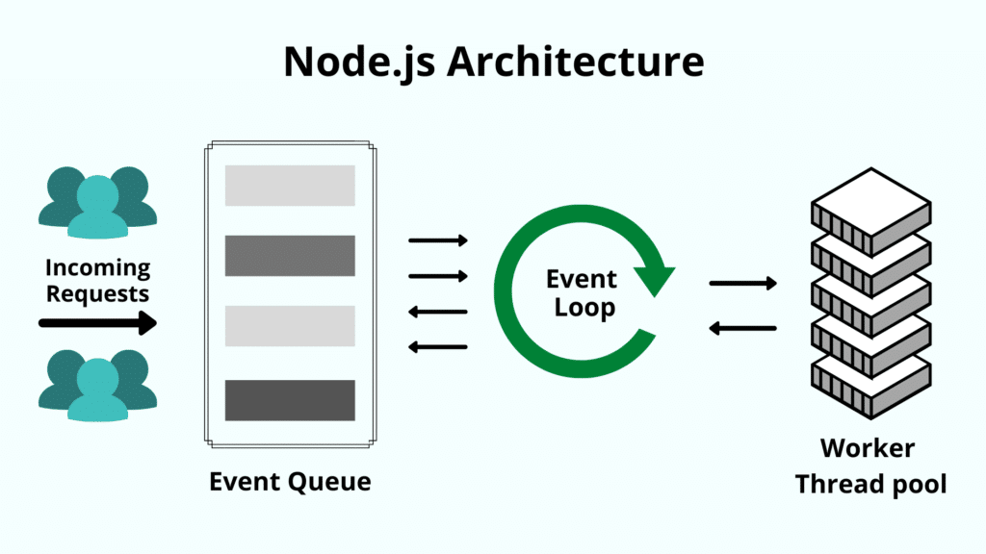In a multi-threaded request-response model, multiple clients send a request, and the server processes each one before sending the response back. However, multiple threads are used to process concurrent calls. These threads are defined in a thread pool, and each time a request comes in, an individual thread is assigned to handle it.

**What is node JS mostly used for?**

It is used for server-side programming, and primarily deployed for non-blocking, event-driven servers, such as traditional web sites and back-end API services, but was originally designed with real-time, push-based architectures in mind.

**References**

[What Is Node.js and Why You Should Use It (kinsta.com)](https://kinsta.com/knowledgebase/what-is-node-js/)

[What Is Node.js? Complex Guide for 2022 (netguru.com)](https://www.netguru.com/glossary/node-js)

[The Node.js Event Loop, Timers, and process.nextTick() | Node.js (nodejs.org)](https://nodejs.org/en/docs/guides/event-loop-timers-and-nexttick/)